**Project Address:**[**https://github.com/langleyfcu/online-banking-system**](https://github.com/langleyfcu/online-banking-system)

After downloading, the following files are available: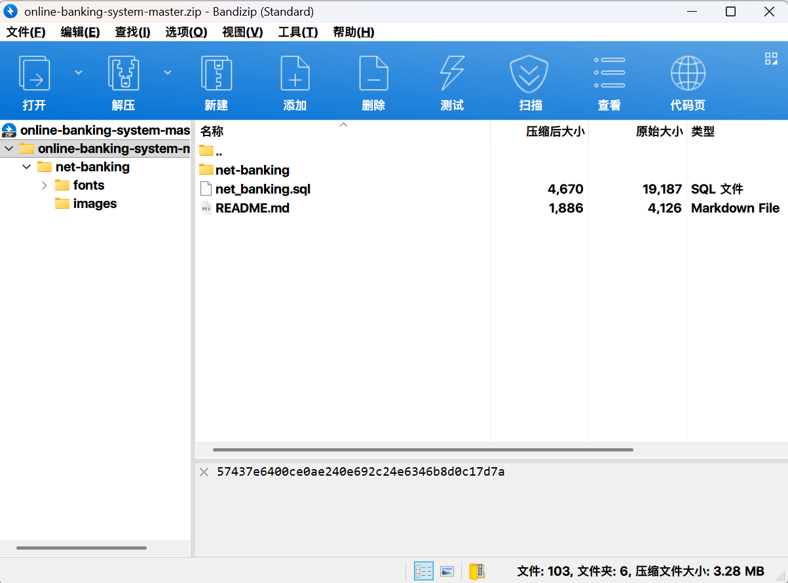

Among them, the **net-banking** folder contains the following files: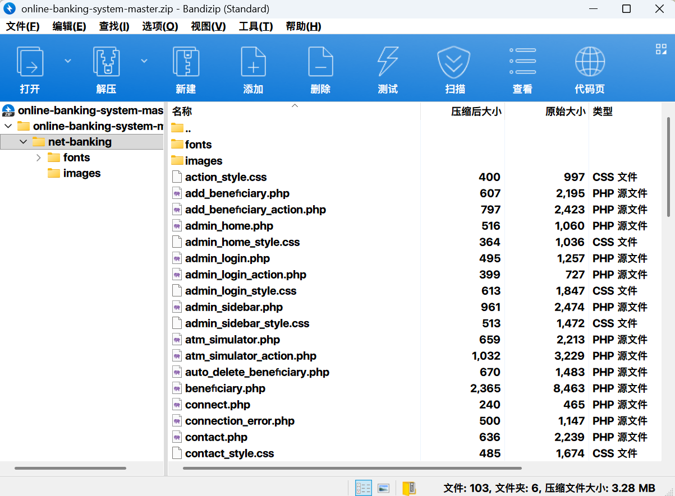

Extract the files from the net-banking folder and place them in the **www root directory** of phpstudy_pro. Here, I implemented this in a virtual machine.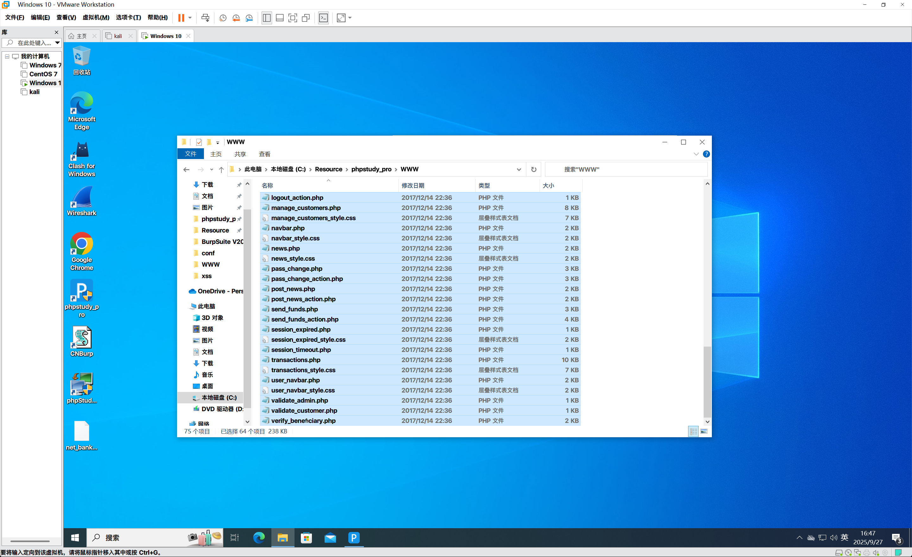

At the same time, create a database named **net_banking** in MySQL, and run the **net_banking.sql** file to create the database required for this project.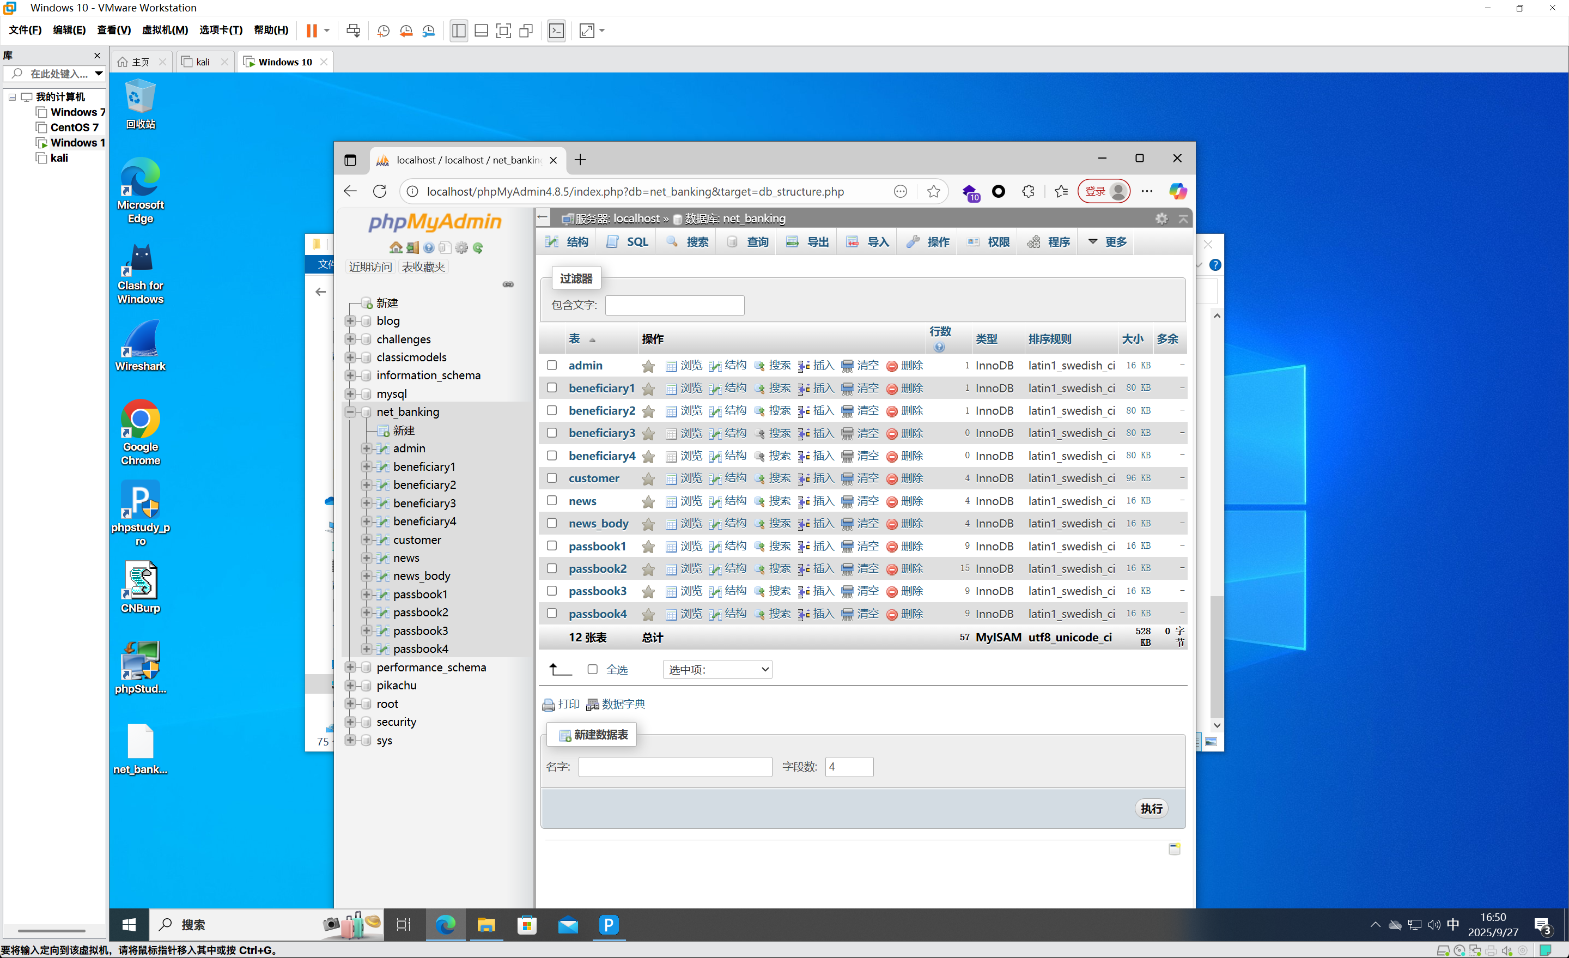

Next, locate the **connect.php** file and modify the database connection information.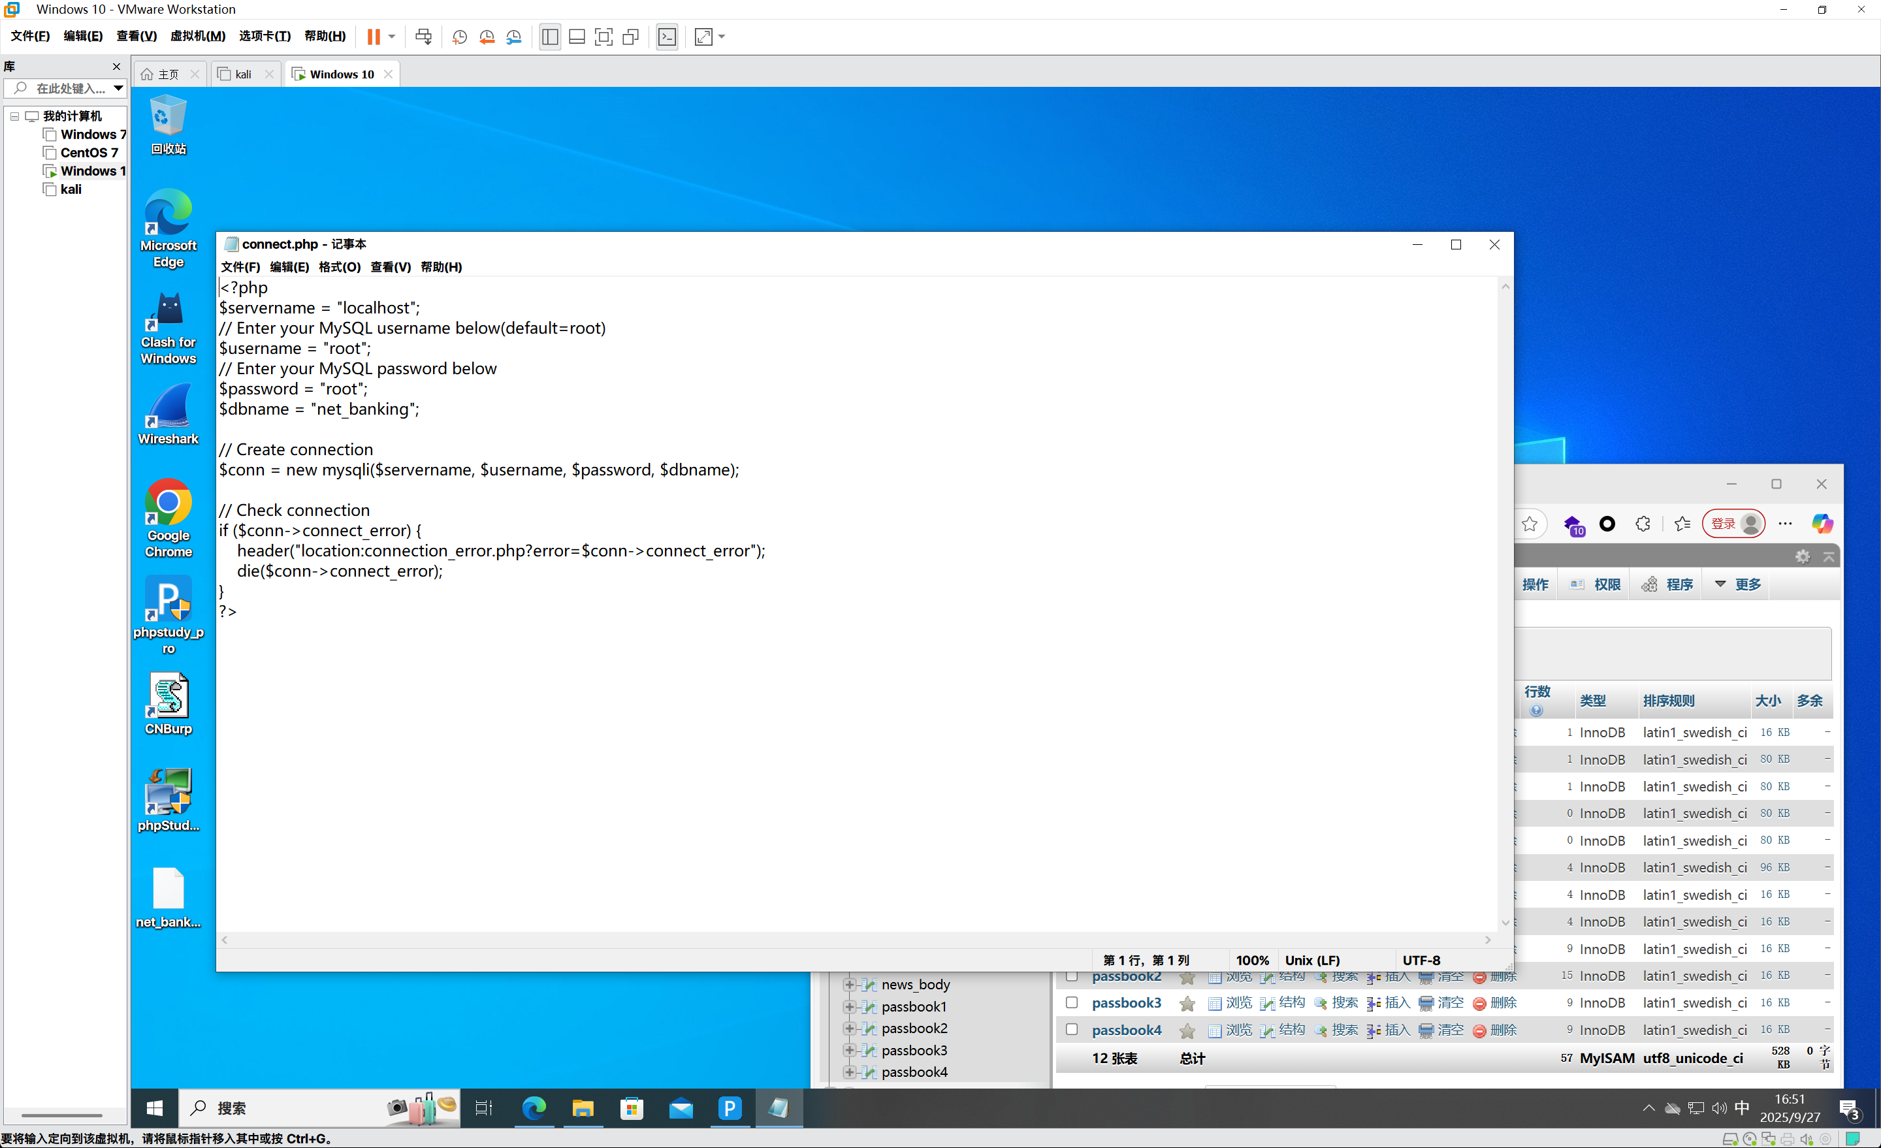

Once the above environment is configured, you can successfully access the project.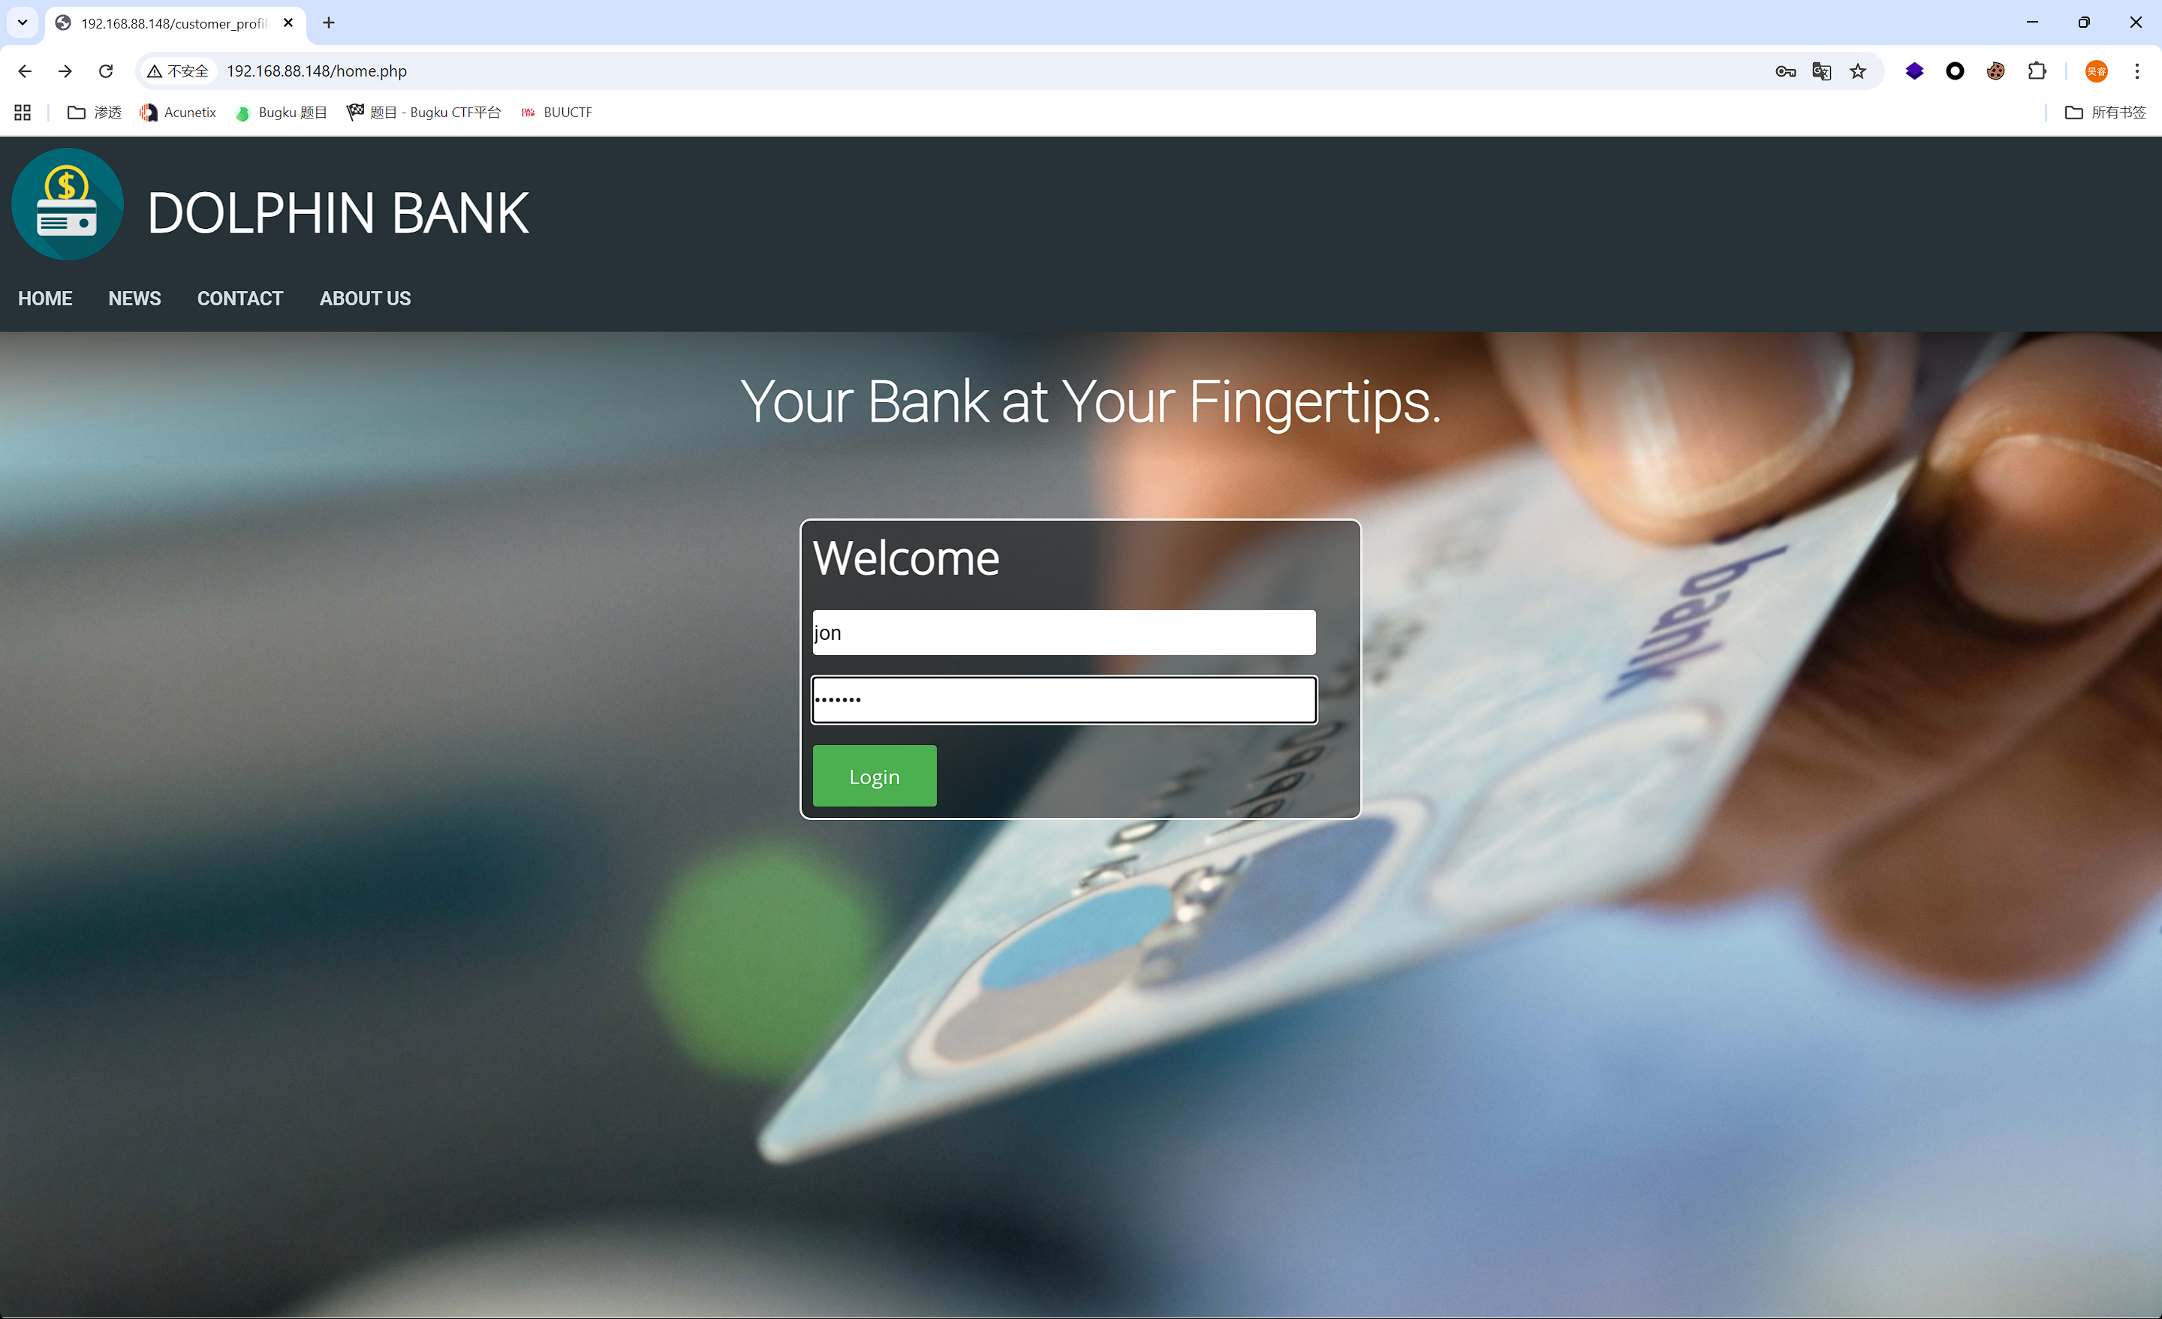

Based on the existing user data in the database:

* Account: jon
* Password: snow123

You can log in successfully.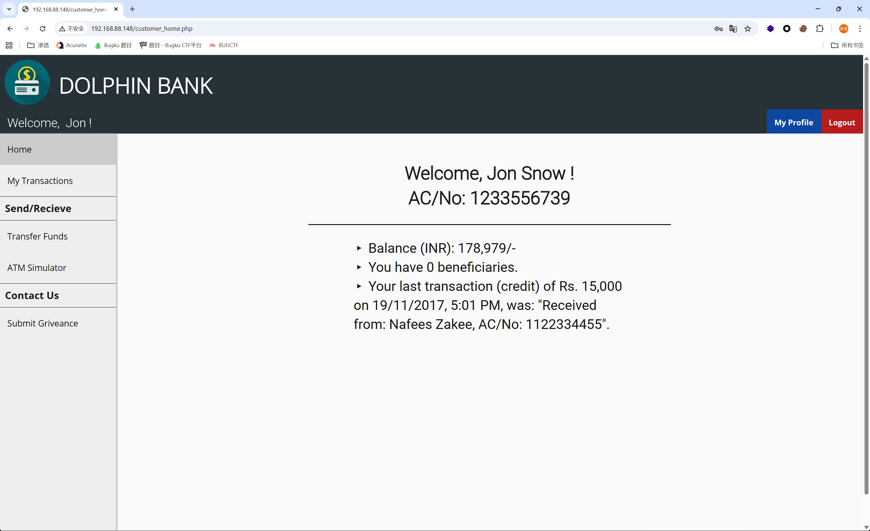

Modify the URL to access **connection_error.php**.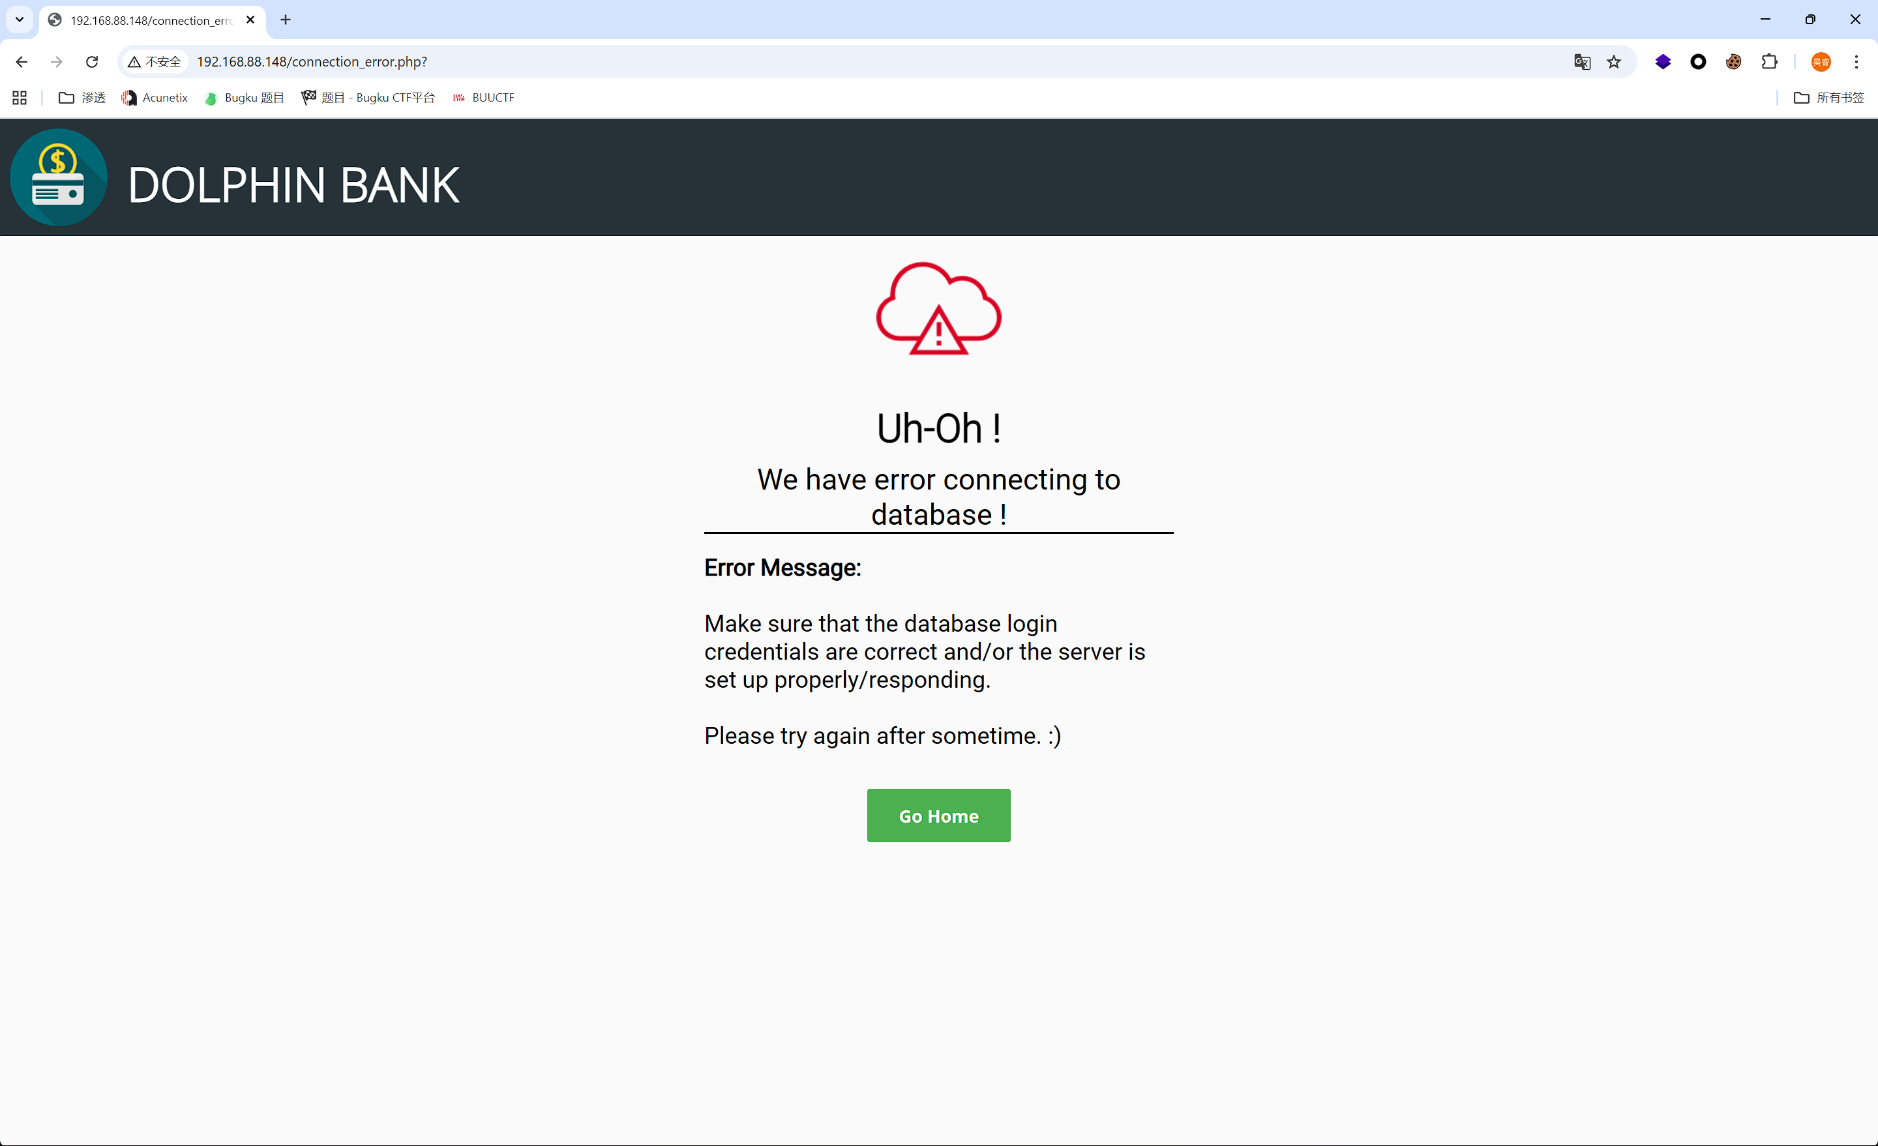

Construct the payload: ?error=<script>alert("XSS")</script>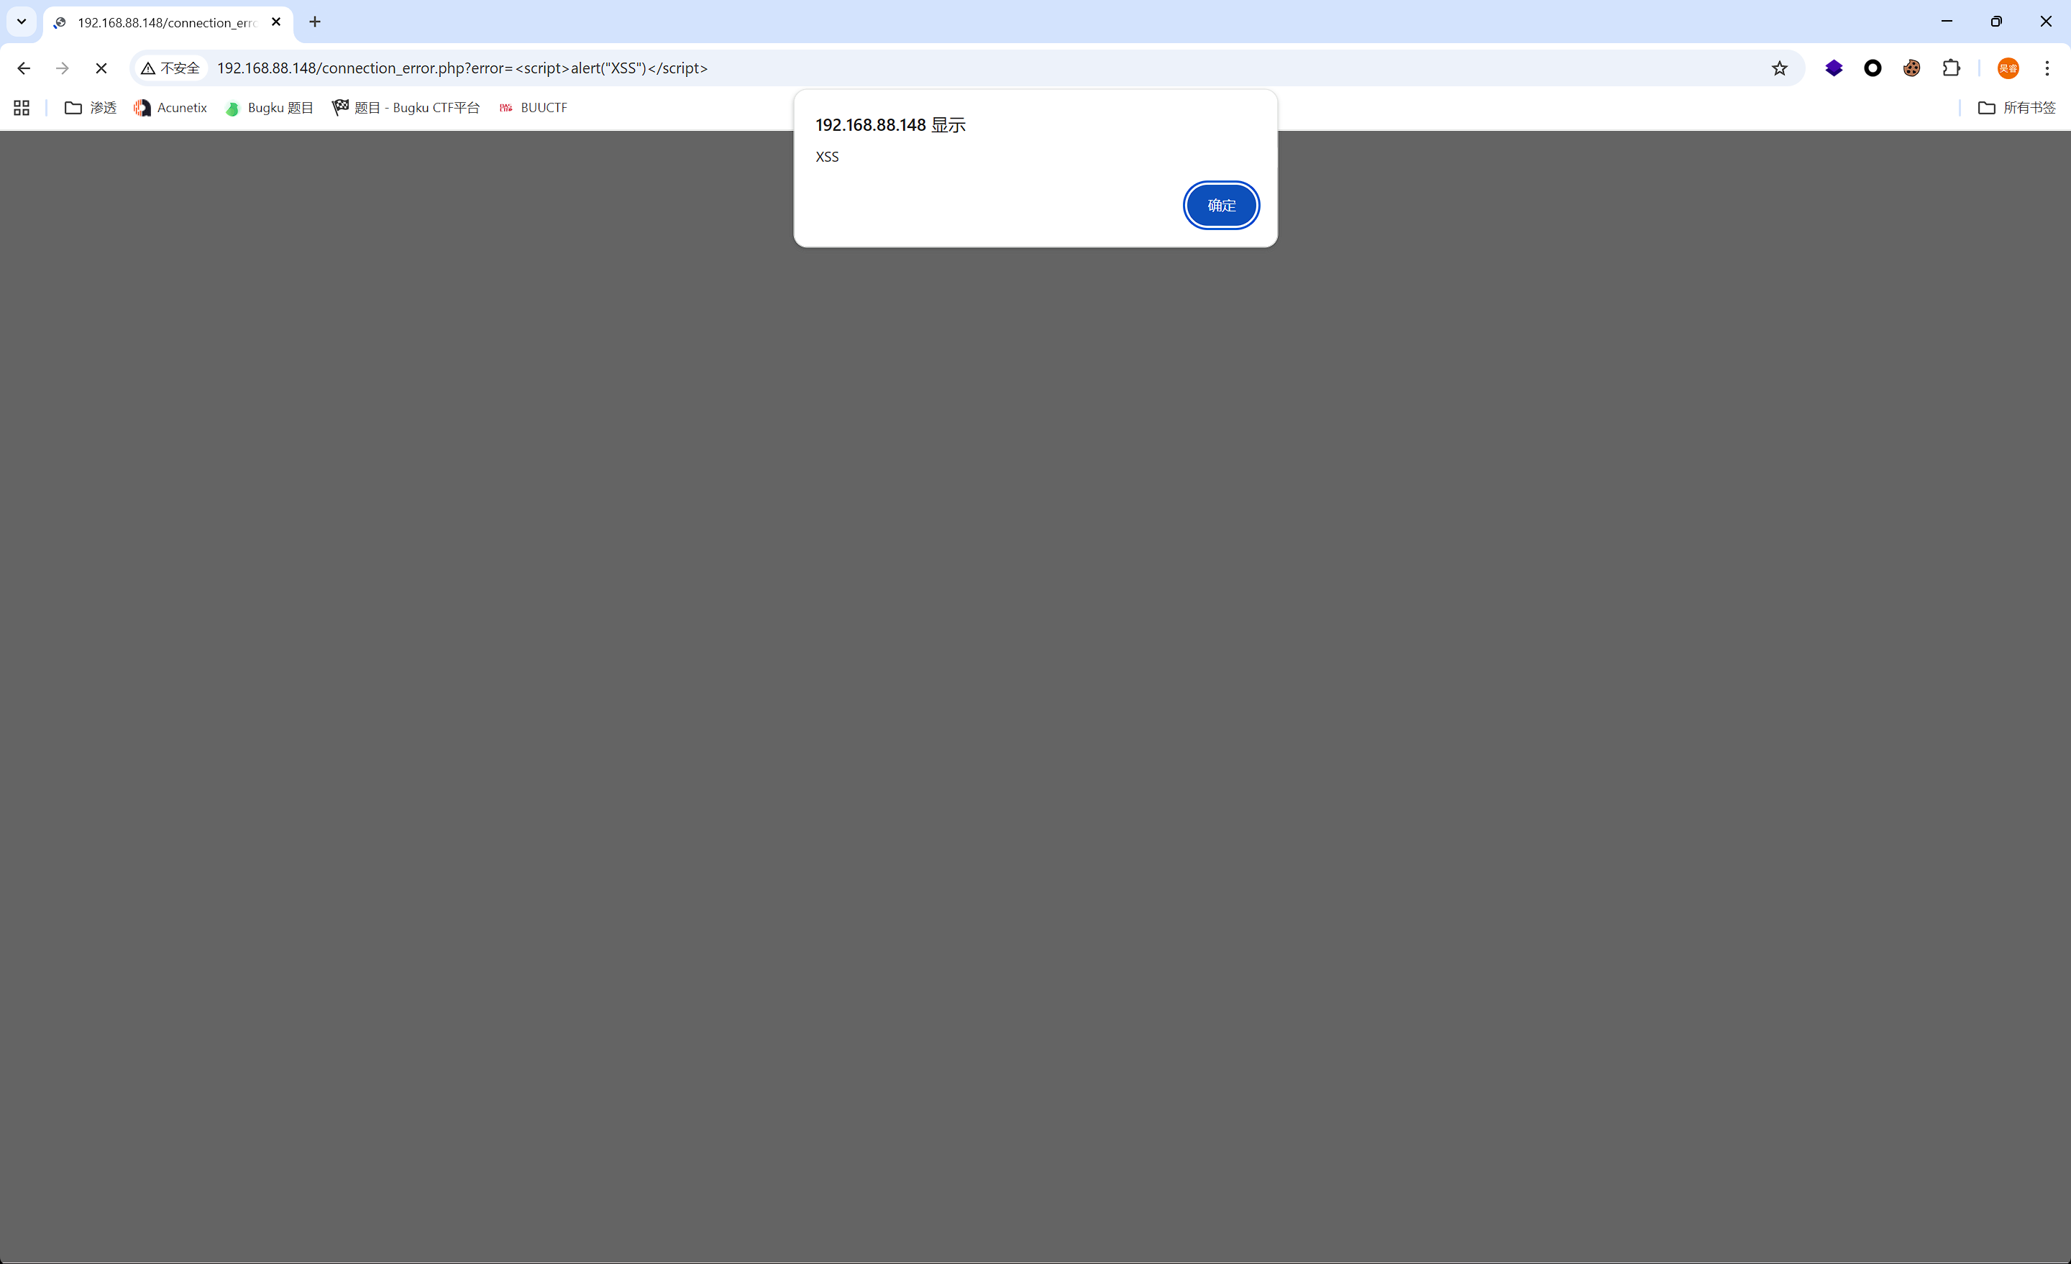

This website has an **XSS vulnerability**